Industry Project 2: Complete Project Report
Oct 13, 2026 · @Prithvi

Summary
We built a Windows desktop system that stops any engraved serial number from being used twice and prints the right label for every new one, running entirely on the client's office network. It is about 80% done: the full system works on macOS, and the next step is testing on the client's Windows PCs.
- Client: a mechanical hardware company that engraves serial numbers on products for two client companies, Dana and TML. One needs barcode labels, the other QR codes (the sample Dana label uses barcodes; which needs QR is still to be confirmed).
- Team: Prithviraj Khedekar and Arnav Pranil Gadge (Team Vicimus).
- What was built: a desktop app with one main computer and several stations, a backup main computer for failures, and an Android phone app that types serials into a station over Bluetooth.
- Running cost: none. Every component is free and open source, and nothing runs in the cloud.
A separate, more detailed report covers the desktop app alone: architecture, security and every edge case handled.

Client requirements
The client's final requirements are a desktop app, used by a few employees on several PCs, that checks every serial for duplicates and prints a barcode or QR label without the data ever leaving their network.
Requirement | Detail
Unique serials | A repeated serial must be caught; the product goes back for re-engraving
Two label types | Barcode for one client company, QR code for the other, chosen automatically
Volume | 400 products a day now, 600+ in the coming months
Users | 4 to 6 employees generate stickers today; not technical
Platform | Desktop application they can download and install
Data stays inside | Must work on the company's own network; no data on the internet
Several scanners at once | Multiple people register serials on separate PCs at the same time
No lock-out | If the main PC fails, another must be able to take over
Input | Manual entry today; phone or camera scanning wanted
Languages | English, Hindi and Marathi
What the client showed us. Their Excel sheet is a product master list (model and 8-digit part number). Each plate carries two engraved lines, the serial (for example 13WAA00101A26) and the part number, in dot-peen engraving. Their past serial records will be shared once the system is shown working.

System at a glance
The final system is one main computer that holds all the data, several stations that ask it, one backup that keeps a live copy, and phones that type into stations.
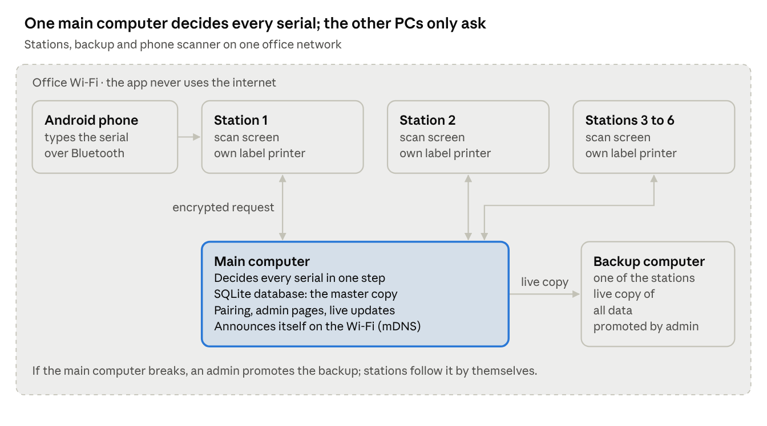
final system · main computer, stations, backup, phone
Stations never decide on their own, which is what makes a missed duplicate impossible even with several people scanning at once.

What we have developed
Three pieces are built: the desktop application (the product the client will use), an Android phone scanner, and the original web app, which is now being retired.
Component | What it is | Status
Desktop app: main computer and stations | Windows app; one PC holds the data and checks every serial, the others register and print | Built, tested on Mac
Duplicate check | One atomic step on the main computer; two stations can never both register the same serial | Built, tested
Pairing and security | Rotating 6-digit code, encrypted traffic, instant removal of a station, admin-only settings | Built, tested on Mac
Automatic discovery | Stations find the main computer on the Wi-Fi with no IP addresses | Built, tested on one Mac
Label printing | Silent printing, barcode or QR by company, label size per company | Built; needs the client's printer
Find serial and reprint | Search any serial; admin reprints, all logged | Built
Excel import and export | Load past serials, export everything; nothing overwritten | Built, tested on Mac
Backup main computer | Live copy on one station; one-button takeover with the admin password | Built; needs a two-PC test
Languages and dark mode | English, Hindi, Marathi; dark mode with a circular reveal | Built; wording to be checked by an operator
Windows installer | One installer for every PC; sets firewall and network automatically | Built, not yet run on Windows
Phone scanner, keyboard mode | Android app types serials into a station over Bluetooth | Built, tested
Phone scanner, camera reading | Read the engraving with the camera, check, send | Not built yet
Web app (first version) | Browser version on Firebase | Built; to be retired

Desktop application
The desktop app is the product the client will run: one installer, used on every PC, that becomes either the main computer or a station on first run.
How a scan works
- The operator types the serial at a station (or the paired phone types it) and presses Enter.
- The station checks the format: A–Z and 0–9 only, matching one of the company's serial patterns.
- The station sends it, encrypted, to the main computer. If the main computer can't be reached, the station refuses to register and keeps retrying; it never stores serials to send later.
- The main computer inserts the serial in one atomic step. If it already exists, the station shows a red screen with the station and time it was first registered.
- If it's new, the main computer saves it, copies it to the backup, and the station shows green and prints the label (barcode or QR, by company).
Main parts
- Main computer: the only machine with the database (SQLite, a single file). It decides every serial, keeps all timestamps, pushes new scans to every station live, and announces itself on the Wi-Fi so stations find it without IP addresses.
- Stations: the scan screen and the label printer. Paired once with a 6-digit code that changes every 30 seconds and is never sent over the network. All traffic is encrypted and pinned to the main computer's certificate. A removed station is locked out instantly.
- Backup main computer: one station keeps a live copy of all data. If the main computer breaks, an admin presses one button on the backup and enters the admin password; stations switch over by themselves. A cut-off main computer pauses itself, so two main computers can never both register.
- Admin pages: Find serial, Excel import and export, Scan History (including imports and reprints), Companies (barcode or QR, serial patterns, label size), Users, Stations.
- For operators: English, Hindi and Marathi; dark mode; Western digits everywhere; a warning if the keyboard is set to Devanagari.
Technology: Electron, a Node.js server inside the app, SQLite, mDNS discovery, SRP-6a pairing, TLS encryption, scrypt passwords, ExcelJS, electron-builder installer. No internet is used at any point.

Phone scanner app
An Android phone pairs with a station PC over Bluetooth and acts as a keyboard, so it can type a serial into the station's serial box with no cables, no Wi-Fi and no extra software on the PC.
- Built (step 1, keyboard mode): the phone pairs as a Bluetooth keyboard, reconnects to the last PC on its own, and types serials exactly (tested into TextEdit and into the station's serial box on a Mac). It reports clearly if a phone doesn't support keyboard mode.
- Not built yet (step 2, camera reading): camera with a guide box and torch, reading the engraving with Google ML Kit on the phone (offline), an editable result the operator checks, and a Send button. It never presses Enter.
- Privacy: no internet permission (the build fails if one is added), no photos or serials saved on the phone.
- Requirements: Android 9 or later, a phone model that allows keyboard mode, and an English keyboard layout on the PC.
The biggest open risk is reading dot-peen engraving accurately, which can only be measured with photos of the client's real plates.

Web application (first version)
The project started as a website on Firebase (cloud database and login), which proved the core flow: type a serial, check for duplicates, show green or red, print the label. It is being retired because the client requires that no data leave their network.
- Its screens, translations, dark mode and label logic were carried into the desktop app, so nothing built was wasted.
- The Firebase project holds only test data. Once the desktop app passes Windows testing, the Firebase code, keys and online project will be deleted.

Testing so far
Everything has been tested on one Mac, running the main computer and several stations side by side; nothing has run on Windows or across separate PCs yet.
Test | Where | Result
Automated desktop tests (server, pairing, discovery, backup) | Mac | 75 passing at last report
Same serial from two stations at the same instant | Automated, 25 runs | Always one new, one duplicate
Main computer setup, admin login, pairing a station | Mac, manual | Works
Registering serials, red duplicate screen | Mac, manual | Works
Excel import (1 new, 2 skipped) and import history | Mac, manual | Works
Phone typing into TextEdit and the station | Mac + Android phone | Exact
First-start connection to its own server | Mac | Failed once before the Local Network permission was granted; worked after restart
Windows install, real printer, two separate PCs, IP change | Not yet | Pending

Future plan
The remaining work is mostly testing and client-specific setup, not new features: finish the open fixes, prove it on Windows, set it up with the client's details, pilot it, then hand over.
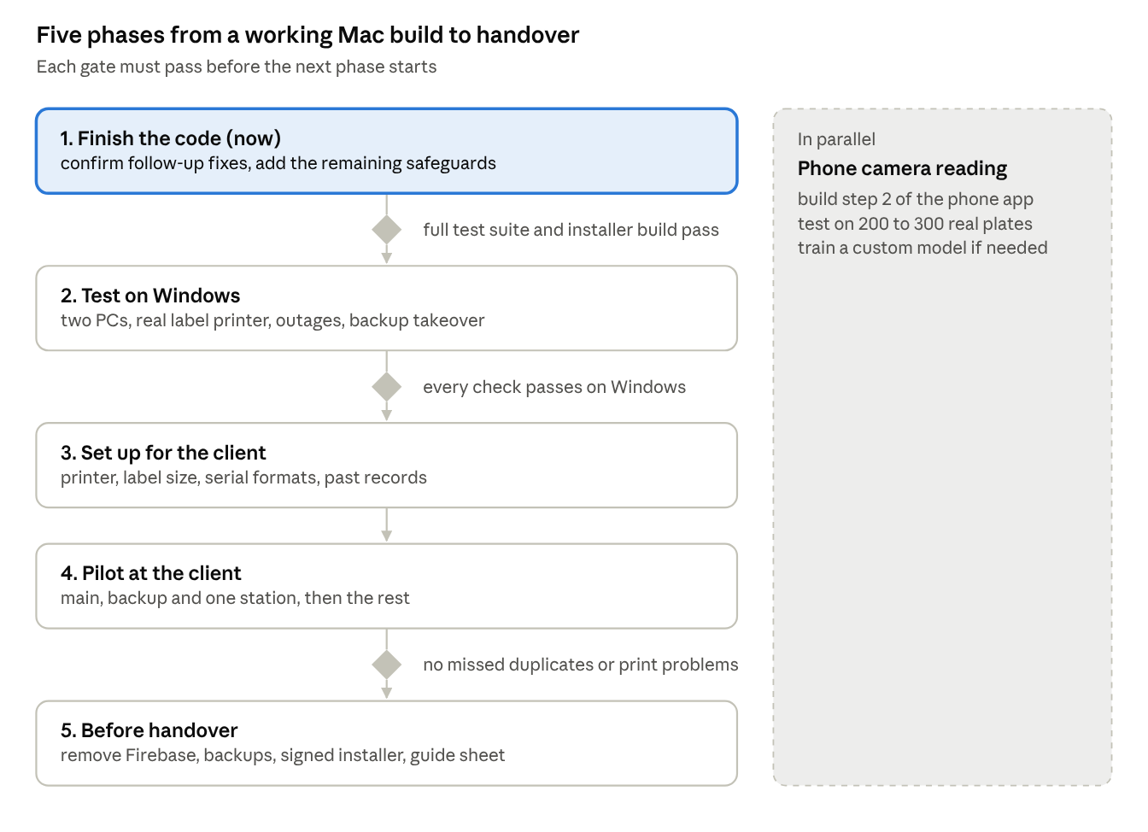
future plan · 5 phases, 3 gates, phone work in parallel
Windows testing is the biggest unknown left, so it comes straight after the code is finished. Phone camera reading runs alongside, since it depends on photos of the client's real plates.

Future plan in detail
Each phase ends with a check that must pass before the next one starts.
- Finish the code
  - Confirm the follow-up fixes: manual server address fallback, main computer running before anyone logs into Windows, staying awake, station setup without logins, admin password recovery code.
  - Add: one main computer per network (block a second one being set up), import report showing when skipped serials were registered, backup copy progress.
  - Gate: the full automated test suite and the Windows installer build pass.
- Test on Windows
  - Install on at least two Windows PCs on the same Wi-Fi: pairing, scanning, duplicates across PCs, printing on a real label printer, main computer switched off, IP address change, promoting the backup, old main computer returning.
  - Gate: every check passes on Windows.
- Set up for the client
  - Their printer model and label size, real serial formats for both companies, QR code contents, which PCs are the main computer and the backup, and an import of their past serial records.
- Pilot
  - Main computer, backup and one station at the client for a few days, then the remaining stations.
  - Gate: no missed duplicates or print problems during the pilot.
- Before handover
  - Remove Firebase and the old web app; scheduled backup files; app icon and a signed installer so Windows doesn't warn; a one-page "if the main computer breaks" sheet for the client.
In parallel: phone camera reading. Build step 2 of the phone app, then measure accuracy on 200 to 300 photos of the client's real plates. If Google ML Kit can't read the dot-peen engraving reliably, train a small custom model on those photos.

Open questions for the client
These answers are needed for phase 3; none of them block the code or Windows testing.
- ☐ Printer model and label size at each station
- ☐ Which client company needs barcodes and which needs QR codes, and what the QR code should contain
- ☐ The real serial formats for both companies, and what each part of a serial means
- ☐ Their past serial records, for importing
- ☐ Which PC will be the main computer and which the backup
- ☐ Number of stations and the shift pattern
- ☐ Who may reprint labels: admins only, or any operator
- ☐ Which text goes on the label description (the sample label and the Excel sheet differ)
- ☐ Android phone model, if they want the phone scanner, and 20 to 30 real plates for photo testing

